EV3 Logic Assessment
- What values can a Logic value have?
  - Number from 0 and 100
  - Letters and words
  - Yes/True and No/False
  - Number of times program looped
- A Logic Loop will repeat when the Logic value wired into it is...
  - Yes/True
  - No/False
  - Wired
  - Missing

- The Logic Loop allows you to...

  - Make a loop that exits based on a custom condition you specify with logic
  - Combine multiple numeric values into one
  - Control more motors
  - Activate sensors more frequently

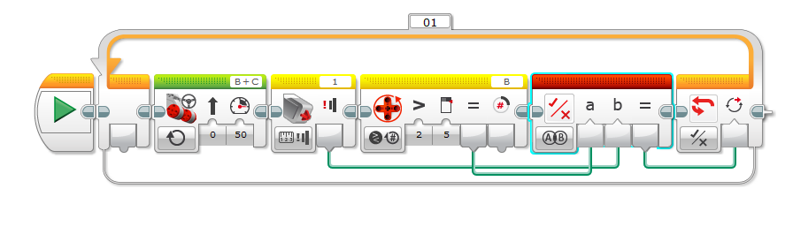

- Ziffle’s program is supposed to stop after the Touch Sensor is pressed or after a certain number of rotations.
  - How many rotations will this program run?

  - Why will this program fail to respond correctly?

  - What will this program actually do?

  - How should it be fixed?

